InﬁniTouch:Finger-Aware Interaction on Fully Touch Sensitive Smartphones

【Main Content】：

We present InfiniTouch, the first system that enables touch input on the whole device surface and identifies the fingers touching the device without external sensors while keeping the form factor of a standard smartphone. We first developed a prototype with capacitive sensors on the front, the back and on three sides.

【BoD】：Back-of-Device (BoD) interaction

【Three common approaches have been proposed in previous work】：

1. using a wearable sensor connected to the user,
2. capturing a hand using a camera, and
3. explaining the shape of the touch.

【Equipment prototype】：

FULL-TOUCH SMARTPHONE PROTOTYPE

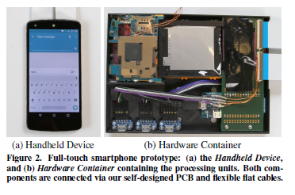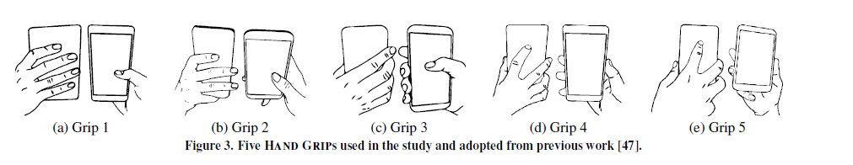

【GROUND TRUTH DATA COLLECTION】：

To record finger motions with sub-millimeter accuracy, we used an OptiTrack motion capture system with eight came-ras (OptiTrack capturing at 240fps). The cameras were firmly mounted to an aluminum profile grid as shown in Figure 4a. To enable these infrared cameras to record the finger movements, we attached 25 reflective markers (6.4mm spherical markers with skin adhesive M3 base) on all joints of the hand similar to previous work [20, 45] and as shown in Figure 4b. Ad-ditionally, we attached four markers on the top part of the full-touch smartphone which enables us to track the device in six degrees of freedom. We installed a display in front of the participant to show instructions (see Figure 4a).

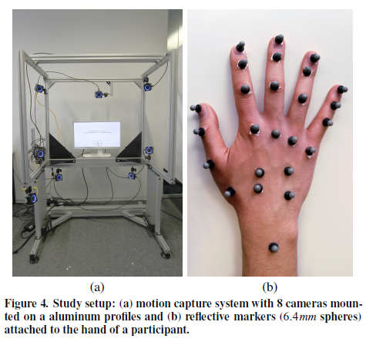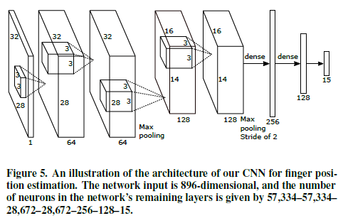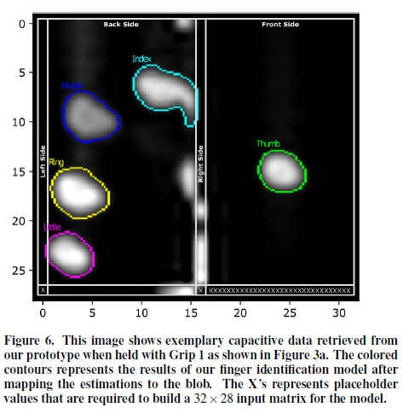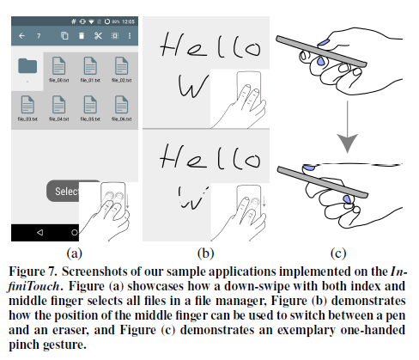

【Independent variable】：

HAND GRIP，FIN-GER and TASK

【FINGER IDENTIFICATION MODEL】：

We train a model to estimate the position of a fingertip using a capacitive image as input. The model output contains the estimated 3D position of each finger, which can also be used to identify the source of the contact area.

【Device implementation】:

We use a combination of full-touch smartphone, CNN and KNN methods to implement InfiniTouch. We introduce our implementation and a set of sample applications.

**Mobile Implementation**

**Using Finger Identification in the Application Layer**

【Sample Use Cases】：

Finger-Specific Touch Gestures

BoD Finger Flexion State as Action Modifier

【Model Accuracy】：(Paper)

【Conclusion】：

We presented InfiniTouch, a smartphone prototype that enables touch input on the whole device surface and identifies fingers touching the device with an accuracy of 95.78%. In contrast to previous approaches for finger-aware input, our prototype is the first that does not require external hardware (e.g., wearable sensors and cameras), has the form factor of a standard smartp-hone, and identifies all fingers during one-handed interaction with a usable accuracy.

【Important Reference】: